REFRIGERATION AND AIR CONDITIONING LABORATORY

LAB SESSION : 5
REVERSED CYCLE REFRIGERATION AND AIR CONDITIONING TRAINING UNIT
OBJECTIVES
- Demonstration of the Basic Refrigeration Cycle by using Automatic (Constant Pressure) Expansion Valve as a Flow Control.
- Demonstration of the Basic Refrigeration Cycle by using Internally Equalised Thermostatic Expansion Valve and the Externally Equalised Thermostatic Expansion.
- Demonstration of Pressure/ Temperature Relation using Evaporator Pressure Regulator and function of Capillary Tube as a Flow Control.
- Demonstration of the Dual Temperature Operation by using Capillary Expansion Device and Internally Equalised Thermal Expansion Valve.
- Demonstration of the Reversed cycle operation, Causes of Excess Discharge Pressure and demonstration of water Cooled Condenser.

DEPARTMENT OF MECHANICAL ENGINEERING &TECHNOLOGY
UNIVERSITY OF ENGINEERING AND TECHNOLOGY LAHORE (KSK CAMPUS)

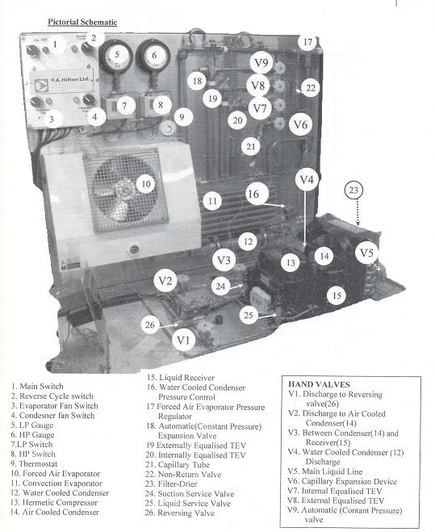
SCHEMATIC:
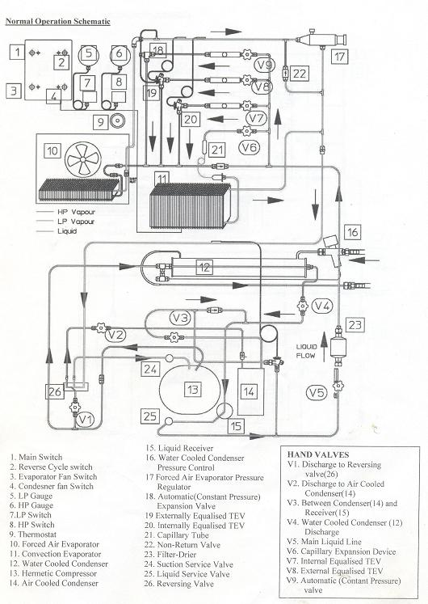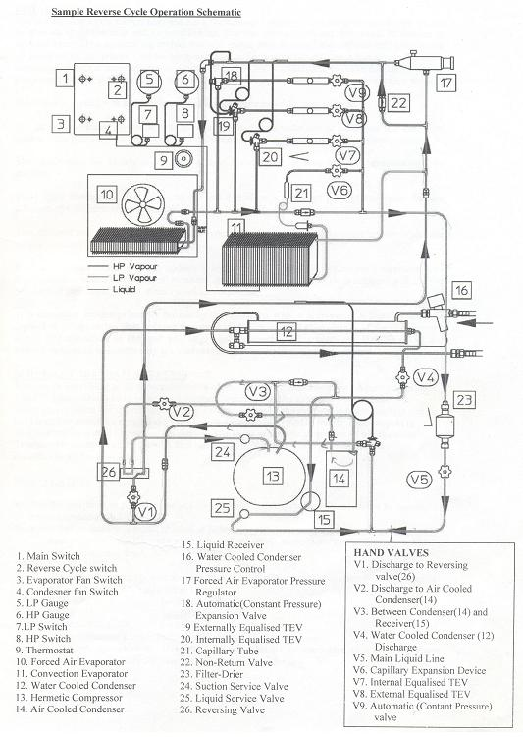
OBJECTIVE 1:
Demonstration of the Automatic (Constant Pressure) Expansion Valve as a Flow Control and the Basic Refrigeration Cycle.
PROCEDURE:
Open hand wheel valve V9. Ensure that V6, V7 and V8 are firmly closed. Valves V1, V2, V3 and V5 on the base OPEN, V4 is closed. Switch ON: The main switch (1), the evaporator fan switch (3), the Condenser fan switch (4).Ensure the Reverse cycle switch (2) is off. Allow the unit to run and settle down. After initial pull down, take the reading from the LP compound gauge (5). The automatic (constant pressure) valve (18) or A.E.V. can be adjusted by turning the slotted adjustor under the plastic cover on the left hand side of the valve, anti-clockwise to lower, clockwise to increase evaporating pressure. Observe the LP gauge pressure. Check and record the working superheat, which initially will be very wide. Check and record temperature drop across the evaporator. Allow the unit to continue to operate and at 10 minute intervals, record superheat and temperature drop reading. Particularly note variations over a time period of at least 1 hour. Use this demonstration first to teach the refrigeration cycle, first by touch, then by thermometer measurement using a single probe, quick reading thermometer.
THE REFRIGERATION CYCLE:
Hot, high pressure vapour from compressor discharge through the reversing valve to the condenser. Note particularly from which leg of the reversing valve the hot gas returns to the condenser. After condensation, sub-cooled but still warm liquid flows from the condenser to the receiver. From the receiver through the compressor service valve, the liquid line, drier and sight glass to the A.E.V. From compressor discharge to the A.E.V. is the High Side of the system. Passing through the A.E.V., liquid flow is throttled and the liquid drops to a los pressure and temperature. At this condition, the liquid will absorb heat from its surroundings and ‘boil-off’. During boiling, the liquid absorbs latent heat. Passing through the evaporator and the suction line back to the compressor, the vapour absorbs sensible heat and becomes superheated. From the A.E.V. to compressor suction is the Low Side of the system. The changes in temperature around the system must be fully understood. If you wish to speed up the demonstration and observe the progression of the frost line, switch off the evaporator fan motor. Don’t allow frost to get back to the compressor. Repeat these demonstrations using different settings of the A.E.V. Log and compare all results with those obtained earlier.

OBJECTIVE 2:
Demonstration of the Basic Refrigeration Cycle by using Internally Equalised Thermostatic Expansion Valve and the Externally Equalised Thermostatic Expansion.
PROCEDURE :( THE INTERNALLY EQUALISED T.E.V.)
If the unit is already running from Experiment No 15. Close the hand wheel valve V9 to the automatic expansion valve (18). And allow the sight glass to empty. Open the hand wheel valve V7 to the Internally Equalized Thermostatic Expansion Valve (20) or TEV. If the unit has not yet been started. Open hand wheel valve V7. Ensure that V6, V7, V8 and V9 are firmly closed. Valves V1, V2, V3, and V5 on the base OPEN, V4 is closed. Switch ON: the main switch (1), the evaporator fan switch (3), the Condenser fan switch (4). Ensure the Reverse cycle switch (2) is off.
Note and record: - (1) HP gauge (6) and LP gauge (5) readings, (2) T.E.V (20). Working Superheat, (3) Temperature Drop across the Evaporator.
Because there is a pressure drop through this evaporator, the internally equalized T.E.V. will have a relatively large superheat. Turn the adjusting spindle (under the hexagonal cap on the valve) clockwise to increase, anti-clockwise to reduce superheat. Note only ¼ turn at a time and allow the system to stabilize after each adjustment. An alternative and more accurate method of measuring superheat can now be used.
NOTE: Working superheat is the difference between the temperature of the T.E.V. thermal bulb and the temperature of the evaporating liquid.
The temperature at the thermal bulb is obtained from the thermometer probe previously fitted at this location. To obtain evaporating temperature, fit a compound gauge to the Evaporator Pressure Regulator (17). This pressure reading, converted to its temperature equivalent, is an accurate measure of evaporating temperature.
NOTE: Any difference between the pressure shown on this gauge and the compound gauge fitted to the unit is pressure drop through the suction line.
Use this demonstration to explain the operation of the Internally Equalized Expansion Valve (20). Particularly explain why, because of pressure drop through the evaporator, the T.E.V. has a wide working superheat. As in Experiment 15, to quickly demonstrate the frost line, switch OFF the evaporator fan.
NOTE: Temperature drop across the evaporator on the 808 will vary according to ambient conditions.

PROCEDURE: (THE EXTERNALLY EQUALISED T.E.V.)
If the unit is already running from exercise above. Close the hand wheel valve V7 to the Internally Equalized Expansion valve (20). And allow the sight glass to empty. Open the hand wheel valve V8 to the Externally Equalized Thermostatic Expansion Valve (19) or TEV. If the unit has not yet been started.
Open hand wheel valve V8. Endure that V6, V7 and V9 are firmly closed. Valves V1, V2, V3, and V5 on the base OPEN, V4 is closed. Switch ON: The main switch (1), the evaporator fan switch (3), the Condenser fan switch (4), Ensure the Reverse cycle switch (2) is off.
As before, note and record: - (1) HP gauge (6) and LP gauge (5) readings, (2) Externally Equalized Thermostatic Expansion Valve (19).Working Superheat, (3) Temperature Drop across the Evaporator.
Explain the difference between the internal and externally equalized T.E.V’s. Particularly explain how the externally equalized T.E.V. compensates for pressure drop through the evaporator. Compare all results with those obtained with the internally equalized T.E.V. To demonstrate the frost line, switch OFF the evaporator fan. Note the difference in frost line between the two T.E.V’s.

OBJECTIVE 3:
Demonstration of Pressure/ Temperature Relation using Evaporator Pressure Regulator and function of Capillary Tube as a Flow Control.
PROCEDURE :( THE EVAPORATOR PRESSURE REGULATOR)
The Evaporator Pressure Regulator can be used to demonstrate the pressure/temperature relation. Set the unit to operate through the externally equalized T.E.V (19) as in Experiment 16. Open hand wheel valve V8. Ensure that V6, V7 and V9 are firmly closed. Valves V1, V2, V3, and V5 on the base OPEN, V4 is closed. Fit a compound gauge to the Evaporator Pressure Regulator (17). Adjust the Evaporator Pressure Regulator by removing the end cap and using a suitable hexagonal key.
NOTE: (a) Turn the adjusting spindle clockwise to increase evaporating pressure. (b) Over adjustment will cause quick pressure drop beyond the Evaporator Pressure Regulator and cause cycling on the low pressure switch. When correct conditions have been established, use this demonstration to reinforce appreciation of the temperature/pressure relationship, i.e. saturated conditions. Re-check and record: - (1) Working Superheated, (2) Temperature Drop across the Evaporator, (3) Gauge Readings
Explain difference in results to those previously obtained. Use this demonstration to explain the use of this important secondary control in conditions where a maintained minimum evaporating pressure, and hence temperature must not be exceeded, e.g.:- (1) Cheese Storage, (2) Liquid (water) Cooling (as water will freeze at$0℃$)
PROCEDURE :( THE CAPILLARY AS A FLOW CONTROL)
To demonstrate the capillary as a flow control: - Switch OFF the evaporator fan switch (3). Open hand wheel valve V6. Ensure that valves. V7, V8 and V9 are firmly closed. Valves V1, V2, V3, and V5 on the base OPEN, V4 is closed. Fit and insulate two thermometer probes:- (1) At the convection evaporator (11) inlet. (2) At the convection evaporator (11) outlet.
Initially set the evaporator thermostat (9) to cut-out at No.3 or a low number. Note that the thermostat temperature sensor is located inside the fins of the convection evaporator (11). Note that in a similar manner to the A.E.V., initial superheat will be very wide. The evaporator thermostat should cut-out at approx. $5℃$ superheat. This will prevent frost back to the compressor. Adjust the setting of the thermostat to obtain this result. The gradual progression of the frost line around the evaporator can be easily observed. Not e especially the essential difference between the A.E.V. and the capillary: - (a) The capillary is NOT adjustable. (b) The capillary allows rapid pressure equalization during the off-cycle and is thus suitable for use on systems using a Low Starting Torque Compressor.

OBJECTIVE 4:
Demonstration of the Dual Temperature Operation by using Capillary Expansion Device and Internally Equalized Thermal Expansion Valve
PROCEDURE: (DUAL TEMPERATURE OPERATION)
Open valve V7 and V6 and close valves V 8 and V9. Valves V1, V2, V3, and V5 on the base OPEN, V4 is closed. This sets thee unit to operate using: - (a) The capillary (21) and the convection evaporator (11). (b) The internally equalized T.E.V (20). SWITCH ON the evaporator fan motor. Locate thermometer probes: - (1) Below the coil block of the forced air evaporator. (2) Pushed into the centre of the convection evaporator. Attach a service gauge to the evaporator pressure regulator (17). Switch on the unit and adjust the evaporator pressure regulator (17) to 2.4 bar g (remove the end cap and adjust with a suitable hexagonal drive key). Note and record all results.
It will be observed that the forced air evaporator maintains a near constant temperature but that the temperature of the convection evaporator continues to fall until cut-out by the evaporator thermostat. Experiment with varying settings on the convection evaporator (11) thermostat (9). Repeat the demonstration with alternative setting s of the Evaporator Pressure Regulator (17), for example, 2.6and 2.8 bar.g.
Repeat the demonstration: - (a) With the forced air evaporator fan OFF. (b) Using the externally equalized T.E.V (19).
At all stages, note, record and compare results. Explain the use of the Evaporator Pressure Regulator (17) in dual temperature fixtures, using only one condensing unit.

OBJECTIVE 5:
Demonstration of the Reversed cycle operation, Causes of Excess Discharge Pressure and demonstration of water Cooled Condenser.

PROCEDURE: (REVERSE CYCLE OPERATION)
Before attempting to demonstrate Reverse Cycle Operation, set the unit to operate through the internally equalized T.E.V (20). With the evaporator fan switch (3) OFF. Valve V7 OPEN valves V6, V8 and V9 Closed. Valves V1, V2, V3, and V5 on the base Open, V4 is closed. Allow sufficient running time to allow a good frost build up on the forced air evaporator (10) coil block.
When satisfied that the correct conditions are established: - (a) Switch to reverse cycle by turning the reverse cycle switch (2) ON. (b) Shut OFF the feed to the internally equalized T.E.V (20) by closing valve V7.
NOTE: (1) Rapid defrosting of the forced air evaporator. (2) The change of function between evaporator and condenser.
The evaporator, now working as a condenser, will be blowing warm air. The condenser, now an evaporator, will be blowing cold air. To demonstrate frost build up on the air cooled condenser (14) now operating as an evaporator, switch OFF the condenser fan motor switch (4). If the compound gauge starts to fall rapidly, it indicates a shortage of liquid in the system. To correct this, open the hand wheel valve V4 in the line from the water-cooled condenser (12). This will pressurize the receiver and force more liquid into the system. Keep a careful watch on the high pressure gauge (6). If it starts to rise quickly, close the hand wheel valve V4 from the water-cooled condenser.
Use this demonstration o explain the operation of the reverse cycle system. Fully explain the reversing valve.
Trace the refrigeration circuit. Show that the discharge gas exits from the reversing valve through the opposite leg to that in demonstration No.15. Show also that the liquid now flows through the original suction line by passing the Evaporator Pressure Regulator (17) and flows in reverse direction through the liquid line via the non return valve (22) to the expansion valve on the condenser. Especially stress that there is no change in the function of the compressor. Carefully tabulate and analyze all results.

PROCEDURE: (EXCESS DISCHARGE PRESSURE)
Explain the causes, e.g. (a) Failed Condenser Fan Motor, (b) Blocked or dirty condenser fins, (c) Condensing Unit wrongly located (e.g. air flow obstructed).
Set the unit for normal operation with the reverse cycle switch (2) OFF. Valve V8 OPEN valves V6, V7 and V9 Closed. Valves V1, V2, V3, and V5 on the base OPEN, V4 is closed. To demonstrate (a), allow the unit to operate normally through the externally equalized T.E.V as above and switch OFF the condenser fan motor switch (4). To demonstrate (b and c), leave the condenser fan motor running and place a sheet of stiff board across the face of the condenser. At all stages, note and record variations in both gauges.

PROCEDURE: (THE WATER COOLED CONDENSER)
To demonstrate the water cooled condenser: Ensure the water supply is connected and turned on. Open hand wheel valve V4 and close V2. Note that the discharge gas now goes directly to the water cooled condenser and back to the receiver. Valves V1, V3, and V5 on the base OPEN. As the air cooled condenser is not now in use, switch OFF the condenser fan motor switch (4). The condenser pressure may be adjusted by turning the central square nut on the top of the water cooled condenser pressure control (16) valve. NOTE that this operates by varying the flow rate of water to the condenser. Increased water flow will result in a lower pressure and reduced a higher pressure. It is recommended that students examine the water flow from the outlet hose. Note that after each adjustment of the valve there will be a delay before the condenser pressure stabilizes. Repeat previous experiments and compare results between air and water cooled condensers. Explain the contra flow system through the water cooled condenser and the operation of the pressure actuated water valve. Experiment and compare results with difference pressure settings of the water valve.

