REFRIGERATION AND AIR CONDITIONING LABORATORY

Lab Session 4
THERMOELECTRIC HEAT PUMP R534
Objectives
- Investigation of the effects upon the surface temperature of either face of the module with increasing power. (Peltier Effect)
- Investigation of the effect upon heat transfer direction of reversing the polarity of the power supply to the module. (Thomson or Lenz Effect)
- Investigation of the variation in open circuit voltage across the module due to the variation in surface temperature difference. (Seeback Effect)
- Investigation of the power generating performance of the module with a steady load and increasing temperature difference.
- Estimation of the coefficient of performance of the module when acting as a refrigerator.

DEPARTMENT OF MECHANICAL ENGINEERING &TECHNOLOGY
UNIVERSITY OF ENGINEERING AND TECHNOLOGY LAHORE (KSK CAMPUS)
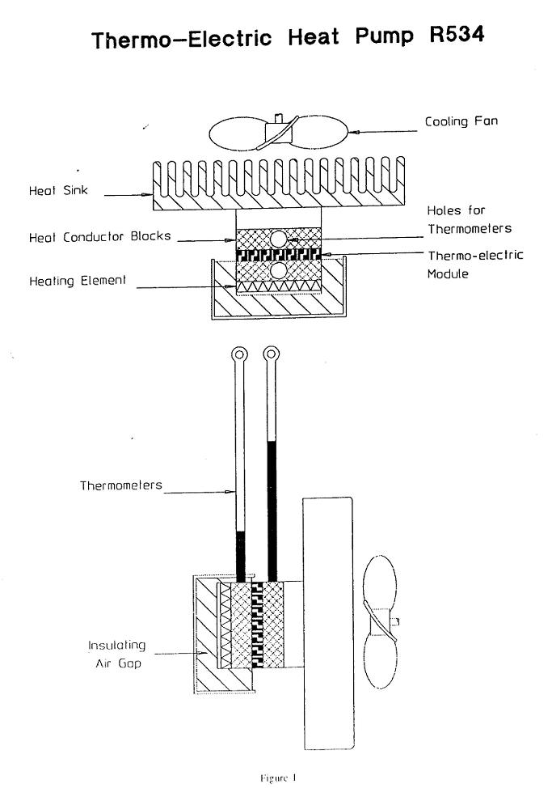
SCHEMATIC:
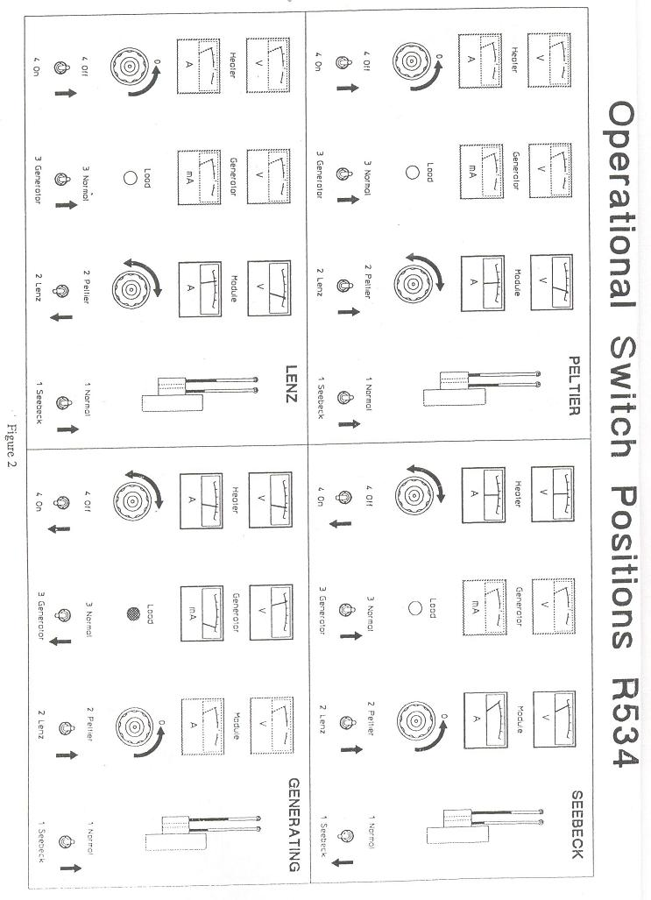
THEORY:
Thermo-Electric Module Assembly
This consists of a series of PN semi-conductor junctions, forming the module, clamped between two thermal conductor blocks. These contain thermometer pockets and allow measurement of the temperature existing on each side of the module. Clamped to the conductor block on the cold side of the module is an electric resistance heater and this is covered by an insulated stainless steel box. The hot side of the module is in thermal contact with a large fan cooled heat sink which is mounted on the inside of the panel. In order to ensure good thermal contact between all of the components the mating faces are smeared with heat transfer compound on assembly and clamped together with a central relating screw.
Control Switches
In order to allow connection of the module and heater in various configurations, without complicated wiring alterations, all of the experimental conditions are established by sequenced switching of four multi-pole switches. Mains power is supplied to the unit through a combined double pole, miniature circuit breaker and overload cut out (5A rating) situated at the top right hand corner of the panel.
Rheostats
Variation of the power supplied to both the heater and thermoelectric module is achieved by two heavy duty rheostats. These are triple graded rotary units in order to achieve near linear control and use a wide silver graphite wiping conductor for long life.
Load Lamp
In order to demonstrate the use of the thermo-electric module in its generating role, a small low voltage lamp is mounted in the centre of the panel. As the temperature difference across the module is increased by the heater, sufficient power is generated to illuminate the lamp.

OBJECTIVE 1:
Investigation of the effects upon the surface temperature of either face of the module with increasing power. (Peltier Effect)
PROCEDURE:
Ensure mains switch is off. Ensure that the thermometers are in position in the holes in the heat conductor blocks in the thermo-electric assembly. Turn the two rheostats fully anti-clock wise. Refer to the PELTIER panel diagram in Figure 2 on page 3 and set the four switches at the bottom of the panel as shown. Switch on the mains switch. Increase the power input to the thermo-electric module (PELTIRE) in increments by turning the right hand rheostat clockwise allowing the temperature to stabilize after each increment. Monitor the relative power input by watching the module (PELTIRE) voltmeter and ammeter. Record $V_{m},I_{m},T_{h}, andT_{c}$ when temperature have stabilised.
HILTON THERMO-ELECTRIC HEAT PUMP
OBSERVATION SHEET Ambient Temperature= 20$℃$
TEST NO |  | 1 | 2 | 3 | 4 | 5 | 6 | 7 | 8
Hot Side Temperature | T_{H} (˚C)
Cold Side Temperature | T_{C} (˚C)
Heater Voltage | V_{h} (Volts)
Heater Current | I_{h} (Amps)
Heater Power | V_{h}×I_{h}=W_{h} (Watts)
Module Voltage | V_{m} (Volts)
Module Current | I_{m} (Amps)
Module Power | V_{m}×I_{m}=W_{m}(Watts)
Module Output | V_{m} (Volts)
Load Current | I_{L} (Amps)
Load Power | V_{m}×I_{L}=W_{L} (Watts)
Module COP as Refrigerator | $$\frac{Wh}{Wm}$$

PLOTS: Draw the following plots:
- Power input to module Vs hot side Temperature.
- Power input to module Vs Cold side Temperature.
- Power input to module Vs T_{H}-T_{C}

COMMENTS

OBJECTIVE 2:
Investigation of the effect upon heat transfer direction of reversing the polarity of the power supply to the module. (Thomson or Lenz Effect)
PROCEDURE:
Ensure mains switch is off. Ensure that the thermometers are in position in the holes in the heat conductor blocks in the thermo-electric assembly. Turn the two rheostats fully anti-clock wise. Refer to the LENZ panel diagram in Figure 2 on page 3 and set the four switches at the bottom of the panel as shown. Switch on the mains switch. Increase the power input to the thermo-electric module (LENZ) in increments by turning the right hand rheostat clockwise allowing the temperature to stabilise after each increment. Monitor the relative power input by watching the module (LENZ) voltmeter and ammeter. Record $V_{m},I_{m},T_{h}, andT_{c}$ when temperature have stabilised.
HILTON THERMO-ELECTRIC HEAT PUMP
OBSERVATION SHEET Ambient Temperature= 20$℃$
TEST NO |  | 1 | 2 | 3 | 4 | 5 | 6 | 7 | 8
Hot Side Temperature | T_{H} (˚C)
Cold Side Temperature | T_{C} (˚C)
Heater Voltage | V_{h} (Volts)
Heater Current | I_{h} (Amps)
Heater Power | V_{h}×I_{h}=W_{h} (Watts)
Module Voltage | V_{m} (Volts)
Module Current | I_{m} (Amps)
Module Power | V_{m}×I_{m}=W_{m}(Watts)
Module Output | V_{m} (Volts)
Load Current | I_{L} (Amps)
Load Power | V_{m}×I_{L}=W_{L} (Watts)
Module COP as Refrigerator | $$\frac{Wh}{Wm}$$

PLOTS: Draw the following plots:
- Power input to module Vs hot side Temperature.
- Power input to module Vs Cold side Temperature.
- Power input to module Vs T_{H}-T_{C}
COMMENTS:

OBJECTIVE 3:
Investigation of the variation in open circuit voltage across the module due to the variation in surface temperature difference. (Seeback Effect)
PROCEDURE:
Ensure mains switch is off. Ensure that the thermometers are in position in the holes in the heat conductor blocks in the thermo-electric assembly. Turn the two rheostats fully anti-clock wise. Refer to the SEEBACK panel diagram in Figure 2 on page 3 and set the four switches at the bottom of the panel as shown. Switch on the mains switch. Increase the power input to the heater (SEEBACK) in increments by turning the right hand rheostat clockwise allowing the temperature to stabilise after each increment. Monitor the relative power input by watching the heater (SEEBACK) voltmeter and ammeter. Record $V_{m},T_{h}, and{ T}_{c}$ when temperature have stabilised.
HILTON THERMO-ELECTRIC HEAT PUMP
OBSERVATION SHEET Ambient Temperature= 20$℃$
TEST NO |  | 1 | 2 | 3 | 4 | 5 | 6 | 7 | 8
Hot Side Temperature | T_{H} (˚C)
Cold Side Temperature | T_{C} (˚C)
Heater Voltage | V_{h} (Volts)
Heater Current | I_{h} (Amps)
Heater Power | V_{h}×I_{h}=W_{h} (Watts)
Module Voltage | V_{m} (Volts)
Module Current | I_{m} (Amps)
Module Power | V_{m}×I_{m}=W_{m}(Watts)
Module Output | V_{m} (Volts)
Load Current | I_{L} (Amps)
Load Power | V_{m}×I_{L}=W_{L} (Watts)
Module COP as Refrigerator | $$\frac{Wh}{Wm}$$

PLOTS: Draw the following plots:
- Temperature difference across Module Vs Module Voltage.

COMMENTS:

OBJECTIVE 4:
Investigation of the power generating performance of the module with a steady load and increasing temperature difference.
PROCEDURE:
Ensure mains switch is off. Ensure that the thermometers are in position in the holes in the heat conductor blocks in the thermo-electric assembly. Turn the two rheostats fully anti-clock wise. Refer to the GENRATING panel diagram in Figure 2 on page 3 and set the four switches at the bottom of the panel as shown. Switch on the mains switch. Increase the power input to the heater (GENRATING) in increments by turning the right hand rheostat clockwise allowing the temperature to stabilise after each increment. Monitor the relative power input by watching the heater (GENRATING) voltmeter and ammeter. Record $V_{m},I_{L}, T_{h}, and{ T}_{c}$ when temperature have stabilised.
HILTON THERMO-ELECTRIC HEAT PUMP
OBSERVATION SHEET Ambient Temperature= 20$℃$
TEST NO |  | 1 | 2 | 3 | 4 | 5 | 6 | 7 | 8
Hot Side Temperature | T_{H} (˚C)
Cold Side Temperature | T_{C} (˚C)
Heater Voltage | V_{h} (Volts)
Heater Current | I_{h} (Amps)
Heater Power | V_{h}×I_{h}=W_{h} (Watts)
Module Voltage | V_{m} (Volts)
Module Current | I_{m} (Amps)
Module Power | V_{m}×I_{m}=W_{m}(Watts)
Module Output | V_{m} (Volts)
Load Current | I_{L} (Amps)
Load Power | V_{m}×I_{L}=W_{L} (Watts)
Module COP as Refrigerator | $$\frac{Wh}{Wm}$$

PLOTS: Draw the following plots:
- Temperature difference across Module Vs Load Power.

COMMENTS:

OBJECTIVE 5:
Estimation of the coefficient of performance of the module when acting as a refrigerator.
PROCEDURE:
Ensure mains switch is off. Ensure that the thermometers are in position in the holes in the heat conductor blocks in the thermo-electric assembly. Turn the two rheostats fully anti-clock wise. Refer to the PELTIRE panel diagram in Figure 2 on page 3 and set the four switches at the bottom of the panel as shown but reset the heater (PELTIRE) switch to ON. This will allow the heater (PELTIRE) to be activated at the same time as the module (PELTIRE) is cooling. Switch on the mains switch. Increase the power input to the heater and module simultaneously in increments such that the cold side temperature is maintained at ambient conditions. Hence it may be assumed that no heat is absorbed from the atmosphere and that all of the heat input from the heater is absorbed by the module in its refrigerating mode. When the temperature are stable record $V_{H}, I_{H} , v_{m} I_{m}, t_{H} andt_{c}.$
HILTON THERMO-ELECTRIC HEAT PUMP
OBSERVATION SHEET Ambient Temperature= 20$℃$
TEST NO |  | 1 | 2 | 3 | 4 | 5 | 6 | 7 | 8
Hot Side Temperature | T_{H} (˚C)
Cold Side Temperature | T_{C} (˚C)
Heater Voltage | V_{h} (Volts)
Heater Current | I_{h} (Amps)
Heater Power | V_{h}×I_{h}=W_{h} (Watts)
Module Voltage | V_{m} (Volts)
Module Current | I_{m} (Amps)
Module Power | V_{m}×I_{m}=W_{m}(Watts)
Module Output | V_{m} (Volts)
Load Current | I_{L} (Amps)
Load Power | V_{m}×I_{L}=W_{L} (Watts)
Module COP as Refrigerator | $$\frac{Wh}{Wm}$$

PLOTS: Draw the following plots:
- Module Input power to maintain Hot side at Ambient Temperature Vs Variation of Module Refrigerating COP wit increasing Load.

COMMENTS:

