REFRIGERATION AND AIR CONDITIONING LABORATORY

Lab Session 2
Refrigeration Basic Unit (TRLLB Equipment)
Objectives:
- Production of heat pump performance curves with different inlet and outlet temperature. Water as a heat source. Heat Pump water-water.
- Lay out of steam compression cycle in a diagram P-H and comparison with the ideal cycle. Water as a heat source. Heat Pump water-water.
- Preparation of the performance curves of the heat pump based on the properties of the refrigerant and at different condensations and evaporation temperatures. Water as heat source. Heat pump water-water

DEPARTMENT OF MECHANICAL ENGINEERING &TECHNOLOGY
UNIVERSITY OF ENGINEERING AND TECHNOLOGY LAHORE (KSK CAMPUS)

SCHEMATIC:

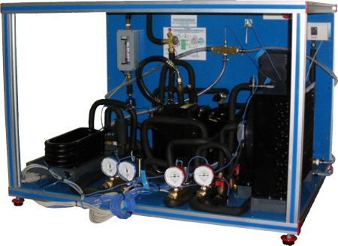
REFRIGERATION BASIC UNIT

APPARATUS:
Refrigeration Basic Unit (TRLLB Equipment)

OBJECTIVE: 1
Production of heat pump performance curves with different inlet and outlet temperature. (Water as a heat source, Heat Pump water-water)
PROCEDURE:
Turned on the apparatus and adjust the water flow until 80$\%$ of the maximal flow, using the flow regulator C-2. Allow the stabilization of the system. Complete the observation table with the values specified on it. Keeping the temperature constant at the water evaporator, reduce the water flow, so the temperature will rise $6℃$ at the outlet of the condenser (ST-2).Allow the stabilisation of the heat pump and repeat the commentaries at similar rises of ST-2 until reaching the value of 65$℃$.
CALCULATIONS:
Specific heat of the water=4180 J/Kg˚C=4.18 J/Kg˚C ; Water density= 0.99997 g/cm³=1.0 g/cm³
1kWh= (1000/3600) W (J/s) ; 1lit/min= (1000/60) cm³/sec;
M_{w}= (C₂ cm³/sec) × (Water Density) ; ${ Q}_{transfered}=M_{w}×C_{p}×\left(T_{2}-T_{1}\right)$
COP = Q_{transfered}/W_{electric}
TABLE/OBSERVATIONS:
Parameters | Units | 1 | 2 | 3 | 4 | 5
Energy consumed by compressor | W (kWh)
Temp. at water inlet condenser | ST-5(⁰C)
Temp. at water outlet condenser | ST-6(⁰C)
Water Inlet flow in condenser | C-2(l/min)
Inlet temp. in water evaporator | ST-3(⁰C)
Mass flow rate in condenser | M_{w} (g/s)
Heat transferred to water | Q_{transf}(J/s)
COP | ----

Specimen Calculations:

W_{electric} = _______×kWh× (1000/3600) = ______W ; C-2=_____× lit/min× (1000/60) =_____cm³/sec
M_{w}= (C₂ cm³/sec) × (Water Density g/cm³) ; M_{w} = _________g/s
Q_{transferred}=M_{w}*Cp*(T₆-T₅) ; Q_{transferred} =__________W
COP = Q_{transferred} / W_{electric} ; COP =____________

PLOTS: Draw the following plots:
- COP Vs condenser water outlet temperature
- Heat output rate Vs condenser water outlet temperature

COMMENTS:

OBJECTIVE 2:
Lay out of steam compression cycle in a diagram P-H and comparison with the ideal cycle. Water as a heat source. Heat Pump water-water.
PROCEDURE:
Using water as heat source, adjusted the water flow in the condenser at an intermediate interval. Contacted the current to the equipment and let it to stabilize. Take note of the values required in the table.

TABLE/OBSERVATIONS:
Parameters | Units | 1 | 2 | 3 | 4 | 5
Refrigerating pressure at the inlet of compressor | M-4(bar)
Refrigerating pressure at the outlet of condenser | M-2(bar)
Refrigerating temp. at inlet of compressor | ST-4(⁰C)
Refrigerating temp. at outlet of compressor | ST-1(⁰C)
Refrigerating temp. at outlet of condenser | ST-2(⁰C)
Refrigerating temp. at outlet of spreading valve | ST-3(⁰C)

From PH diagram we obtained the following Values;

No of Obs. | h₁(kJ/kg) | h₂(kJ/kg) | h₃=h₄(kJ/kg) | h_{2s}(kJ/kg)
1
2
3
4

SPECIMEN CALCULATIONS: (for first set of readings)
Draw the points on p-h diagram as follows
- Is located by the intersection of M-4= _______________and ST-4= ___________
- Is located by the intersection of M-2= _______________and ST-1= ___________
(2s) Is located by assuming constant entropy compression from state point (1) and
M-2=________, (S_{2s}=S₁)
- Is located by the intersection of M-2 = ______________ and ST-2= ________
- Is located by the intersection of ST-3= ______________ and h₃=h₄
(4΄) Is located by the intersection of M-2= ______________ and h₃=h₄
The following readings were taken from p-h diagram
h₁ = h₂ = h_{2s} = h₃ = h₄ =
COMMENTS:

OBJECTIVE 3:
Preparation of the performance curves of the heat pump based on the properties of the refrigerant and at different condensations and evaporation temperatures. Water as heat source . Heat pump water-water
PROCEDURE:
Selected water as heat source and turned the evaporator flow to the maximal one. Adjusted the water in the condenser at a high flow and connected the equipment to the electric current. When the equipment had stabilized, took note of the pressure of the condenser (M-2) and the temperature of the evaporator (ST-3).Adjusted the water flow until ST-3 reached its initial value. Once stabilized, repeated the annotations. Repeated the trial with increase of 100KN/m² in the sensor SP-2 until the manometric pressure reached more or less 1400KN/m².Repeated the experience with other constant valve of ST-3 (in order to increase the value of ST-3, increased the water flow of the evaporator and to decrease it, decreased that flow).
CALCULATIONS:
Specific heat of the water=4180 J/Kg˚C=4.18 J/Kg˚C ; Water density= 0.99997 g/cm³=1.0 g/cm³
Density of R134a = 1225 g/cm³ ; 1kWh= (1000/3600) W (J/s) ; 1lit/min= (1000/60) cm³/sec
M_{r}= (C₁ cm³/sec) × (Density of R134a) ; Heat produced inside the condenser=Q₁=M_{r}× (h₃-h₂)
M_{w}= (C₂ cm³/sec) × (Water Density); Heat transferred inside the condenser to water=Q₃=Mw×Cp× (T₆-T₅)
COP₁ = Q₁/W_{electric} ; COP₂ = (h_{2s} – h₃)/(h_{2s} – h₁) ; COP = Q₃/W_{electric}

TABLE/OBSERVATIONS:
Parameters | Units | 1 | 2 | 3 | 4 | 5
Energy used by compressor | W(kWh)
Flow of refrigerant | C-1 (1/min)
Pressure of refrigerant at condenser outlet | M-2 (bar)
Temp. of refrigerant at compressor inlet | ST-4 (⁰C)
Temp. of refrigerant at compressor outlet | ST-1 (⁰C)
Temp. of refrigerant at condenser outlet | ST-2 (⁰C)
Temp. of refrigerant at evaporator inlet | ST-3 (⁰C)
Outlet temp. of water evaporator | ST-7 ( ⁰C)
Water evaporator flow | C-3 (1/min)
Water inlet temp. at condenser | ST-5 (⁰C)
Water outlet temp. at condenser | ST-6 ( ⁰C)
Water flow at condenser | C-2 (1/min)
Mass flow rate of Refrigerant | M_{r} (g/s)
Mass flow rate of water in condenser | M_{w} (g/s)

Sr. # | h₁(kJ/kg) | h₂(kJ/kg) | h₃=h₄(kJ/kg) | h_{2s}(kJ/kg) | Q₁(W) | Q₂ (W) | COP₁ | COP₂ | COP₃
1
2
3
4

SPECIMEN CALCULATION: (for 4th set of reading)
Draw the state points on p-h diagram as follows:
- Is located by the intersection of M-4 = ___________ and ST-4= _______
- Is located by the intersection of M-2 = ___________ and ST-1= _______
(2s)Is located by assuming constant entropy compression from state point (1) and
M-1=________, (S_{2s}=S₁)
- Is located by the intersection of M-2 = ___________ and ST-2= _______
- Is located by the intersection of ST-3 = ___________ and h₃=h₄
The following readings were taken from p-h diagram
h₁ = h₂ = h_{2s} = h₃ = h₄ =
W_{electric} = _______×kWh× (1000/3600) = ______W ; C-1=_____× lit/min× (1000/60) =_____cm³/sec
C-2=_____× lit/min× (1000/60) =_____cm³/sec ; M_{r}= (C₁ cm³/sec) × (Density of R134a g/cm³)
M_{r} = _________g/s ; M_{w}= (C₂ cm³/sec) × (Water Density g/cm³)

M_{w} = _________g/s ; Q₁=M_{r}× (h₃-h₂) =_____________W
Q₃=Mw×Cp× (T₆-T₅)=_____________ ; COP₁ = Q₁/W_{electric} =_______________
COP₂ = (h_{2s} – h₃)/(h_{2s} – h₁) =_____________ ; COP = Q₃/W_{electric}= _____________
PLOTS: Draw the following plots:
- COP₁ ,COP₂ ,COP₃ Vs Condenser water outlet temperature
- Heat Produced (Q₁) Vs condenser water outlet temperature
COMMENTS:
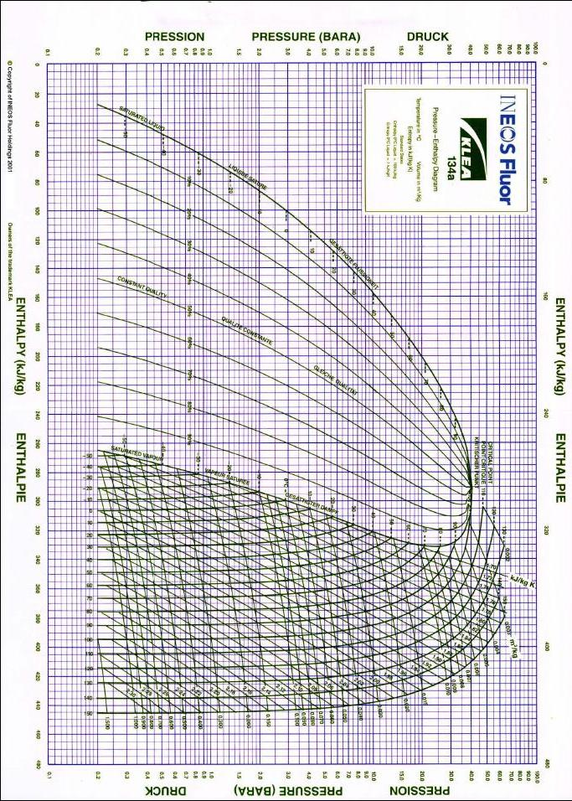
OBSERVATIONS TABLE FOR ALL EXPERIMENTS
Atmospheric Pressure = _____________mm Hg
Atmospheric Temperature =______________˚C
Parameters | Units | 1 | 2 | 3 | 4 | 5
Energy used by compressor | W(kWh)
Flow of refrigerant | C-1 (1/min)
Water Flow at condenser | C-2 (1/min)
Water evaporator Flow | C-3 (1/min)
Pressure of refrigerant at compressor outlet | M-1 (bar
Pressure of refrigerant at condenser outlet | M-2 (bar)
Pressure of refrigerant at evaporator inlet | M-3 (bar)
Pressure of refrigerant at compressor inlet | M-4 (bar)
Temp. of refrigerant at compressor outlet | ST-1 (⁰C)
Temp. of refrigerant at condenser outlet | ST-2 (⁰C)
Temp. of refrigerant at evaporator inlet | ST-3 (⁰C)
Temp. of refrigerant at compressor inlet | ST-4 (⁰C)
Water inlet temp. at condenser | ST-5 (⁰C)
Water outlet temp. at condenser | ST-6 ( ⁰C)
Outlet temp. of water evaporator | ST-7 ( ⁰C)

