REFRIGERATION AND AIR CONDITIONING LABORATORY

Lab Session No: 1
Mechanical Heat Pump
Objectives of the Experiment:
- To determine the Coefficient of Performance of heat Pump and production of Heat Pump performance curves over a range of source and delivery temperatures.
- Comparison of practical and Ideal Cycles on a P-H Diagram and determination of energy balance for Condenser and Compressor.
- Production of Heat Pump performance curves based on the R134a properties at a variety of Evaporating and Condensing temperatures.
- Estimation of the effect of Compressor Pressure Ratio on Volumetric Efficiency.

DEPARTMENT OF MECHANICAL ENGINEERING & TECHNOLOGY
UNIVERSITY OF ENGINEERING AND TECHNOLOGY LAHORE (KSK CAMPUS)
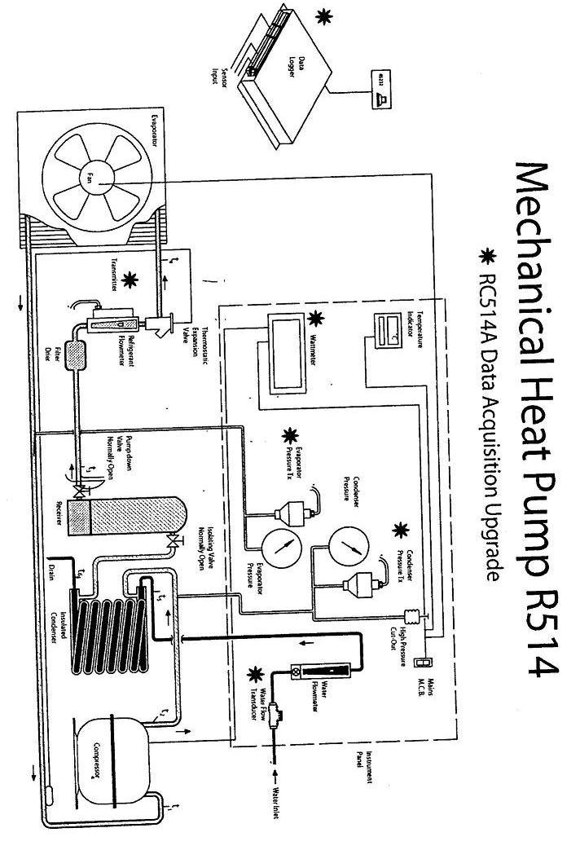
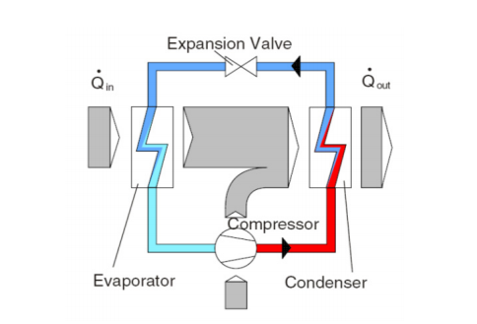
SCHEMATIC:

Fig. 1: Vapor Compression Refrigeration Cycle
THEORY:
Schematic of a vapour compression refrigeration cycle is shown in Fig. 1; this cycle has the following component:
- A compressor which compresses the vapor of refrigerant. It consumes electrical power and provides the required mechanical energy (work) to the system.
- The condenser that absorbs heat (at constant pressure) from the hot and high pressure refrigerant and transfers it to the high temperature source.
- An expansion (throttling) valve that expands the liquid working medium during a constant enthalpy process.
- An evaporator facilitates the evaporation of the refrigerant while it absorbs heat from the low temperature reservoir.
The pressure-enthalpy diagram for an ideal refrigeration cycle is shown in the Fig. 2 given below, which includes the following processes:
- 1-2: Isentropic compression of the refrigerant from saturated vapour to superheated vapour (adiabatic process).
- 2-2’: Isobaric heat transfer (cooling) to the condensation temperature,
- 2’-3: Isobaric condensation, releasing the condensation enthalpy,
- 3-4: Isenthalpic expansion from saturated liquid to mixture of gas and liquid,
- 4-1: Isobaric evaporation, absorption of the evaporation enthalpy,
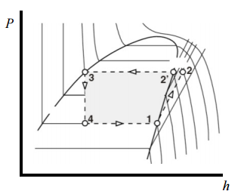

Fig 2: Pressure-enthalpy diagram of an ideal refrigeration cycle

As shown in Fig. 3, the key difference between the real cyclic process and the ideal cyclic process is that in reality the compression process is not isentropic; process 1’-2’ in Fig. 3. Thus, in actual cycle more work must be expended at the compressor to achieve the same final pressure as in the ideal cycle. In addition, in the actual cycle superheating of the refrigerant is necessary prior to compression (process 1-1’ in Fig. 3) to avoid the possibility of the entry of liquid droplets into the compressor. Otherwise the compressor blades would be damaged by the impact of liquid droplets. By means of liquid sub-cooling (3-3’) the vapor portion in the mixture is reduced (compare state 4 with 4’) and more heat can be transferred in the evaporator. Hence, more evaporation heat is absorbed (4’- 1’).
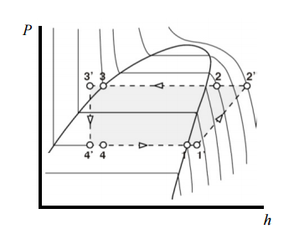

Fig 3: Pressure-enthalpy diagram of a real refrigeration cycle

PROCEDURE:
Switch on the vapor-compression refrigeration apparatus after taking care of all necessary precautions. Allow running of the apparatus for a while so that the readings shown become stable. Change the condenser water flow rate using the knob provided, for each set of readings. Insert the values in the table of observations.

OBJECTIVE No. 1:
To determine the Coefficient of Performance of heat Pump and production of Heat Pump performance curves over a range of source and delivery temperatures.
CALCULATIONS:
Work input rate across compressor w_{com} = 4500/ X (I)
Heat Output across condenser q_{con} = m_{w} x C_{p w} (T₆ – T₅) (II)
Coefficient of Performance COP = Heat Output / Work Input (III)

TABLE/OBSERVATIONS:
Sr. No | Condenser water flow rate  (g/s) | Condenser Water temperatures  outlet/inlet  (°C) |  | Time per rev of energy meter  (s) | Compressor work input rate  (kW) | Heat Output  across  condenser  (kW) | COP  of heat pump  (ND)
 | m_{w} | T₆ | T₅ | X | w_{com} | q_{con}
1
2
3
4

SPECIMEN CALCULATION: (for first set of reading)
The energy meter installed on the apparatus is based on the following relationship:
800 Flashes Per kilo-watt-hour (kWh) corresponds 3.6 x 10⁶ Joules (J) i.e. 1 kWh
1Flash Per kilo-watt-hour (kWh) corresponds (3.6 x 10⁶) / 800 Joules (J) and that equals 4500 J.
If ‘X’ is time for one Flash of Energy Meter then
Power Input = 4500/X J/s
Hence
Work Input rate (w_{com}) = 4500/X.
(w_{com})= _____ kW
Heat output rate (q_{con}) = m_{w} x C_{P} x (T ₆ – T₅₎.
(q_{con}) = _____ kW
Now
COP = ________
PLOTS: Draw the following plots:
- COP Vs condenser water outlet temperature
- Compressor power input rate Vs condenser water outlet temperature
- Heat output rate Vs condenser water outlet temperature

COMMENTS:

OBJECTIVE No. 2:
Comparison of practical and Ideal Cycles on a P-H Diagram and determination of energy balance for Condenser and Compressor.
CALCULATIONS:
Heat Transfer from Refrigerant = m_{r} (h₂ –h₃) (I)
Heat Transfer to water = m_{w} C_{p} (T₆ – T₅) (II)
Electrical Power input to Compressor = 4500/ X (III)
Enthalpy change of R134a = m_{r} (h₂ –h₁) (IV)
TABLE/OBSERVATIONS:
Sr.  No | Pressure  at  Comp. suction  (kN/m⁻²) | Pressure  at  Comp. delivery  (kN/m⁻²) | Temp.  at Comp. suction  (º C ) | Temp.  at Comp. delivery  (º C ) | Temp.  at  Cond. outlet  (º C ) | Temp.  at  Ex. Valve outlet  (º C ) | Water mass flow rate  g/s | Ref.  mass flow rate  g/s | Time  Per rev.  (s) | Cond.  Water  Temps.  In/Out
 | P₁ | P₂ | T₁ | T₂ | T₃ | T₄ | m_{w} | m_{ref} | X | T₅ | T₆
1
2
3
4

SPECIMEN CALCULATIONS: (for first set of readings)
Draw the points on p-h diagram as follows
- Is located by the intersection of P₁= _______________and T₁= ___________
- Is located by the intersection of P₂= _______________and T₂= __________
(2s) Is located by assuming constant entropy compression from state point (1) and
P₂=______, (S_{2s}=S₁)
- Is located by the intersection of P₃ = ______________ and T₃= ________
- Is located by the intersection of T₄ = ______________ and h₃=h₄

The following readings were taken from p-h diagram
h₁ = h₂ = h_{2s} =
h₃ = h₄ = v₁ = v_{1s} =
ENERGY BALANCE:
Condenser
Heat Transfer from Refrigerant = m_{r} (h₂ –h₃) =____________
Heat Transfer to water = m_{w} C_{p} (T₆ – T₅) = _____________
Compressor
Electrical Power input to Compressor = 4500/ X = ______________
Enthalpy change of R134a = m_{r} (h₂ –h₁)
COMMENTS:

OBJECTIVE No. 3:
Production of Heat Pump performance curves based on the R134a properties at a variety of Evaporating and Condensing temperatures.
CALCULATIONS:
Work input rate across Compressor w_{com} = 4500 / X (I)
Heat Transfer in Condenser q_{con} = m_{r} x ₍h₂ – h₃) (II)
Heat Transfer in Evaporator q_{evap} = m_{r} x ₍h₁ – h₄) (III)
Coefficient of Performance COP = q_{con} / w_{com} (IV)
TABLE/OBSERVATIONS:
Sr. No | Pressure  at 1  kN/m⁻² | Pressure  at 2  kN/m⁻² | Temp  at 1  (ºC ) | Temp  at 2  (ºC ) | Temp  at 3  (º C ) | Temp  at 4  (º C ) | Ref.  flow rate  (g/s⁻¹) | Time  Per rev.  (s) | Cond.  Water Temps.  In/Out |  | H.T.  In  Evap  (W) | H.T.  in Cond  (W) | Comp  Input  (W) | COP
 | P₁ | P₂ | T₁ | T₂ | T₃ | T₄ | m_{ref} | X | T₆ | T₅ | q_{evap} | q_{cond} | w_{com}
1
2
3
4

SPECIMEN CALCULATION: (for 4th set of reading)
Draw the state points on p-h diagram as follows:
- Is located by the intersection of P₁ = ___________ and T₁= _______
- Is located by the intersection of P₂ = ___________ and T₂= _______
- Is located by the intersection of P₃ = ___________ and T₃= _______
- Is located by the intersection of T₄ = ___________ and h₃=h₄

The following readings were taken from p-h diagram
h₁ = h₂ = h₃ = h₄ =
Work input rate across Compressor w_{com} = 4500 / X (I)
w_{com} =
w_{com} =
Heat Transfer in Condenser q_{con} = m_{r} x ₍h₂ – h₃) (II)
q_{con} =
q_{con} =
Heat Transfer in Evaporator q_{evap} = m_{r} x ₍h₁ – h₄) (III)
q_{evap} =
q_{evap} =
Coefficient of Performance COP = w_{com} / q_{con} (IV)
COP =
COP =
PLOTS: Draw the following plots:
- COP Vs Condenser water outlet temperature
- Compressor power input rate Vs condenser water outlet temperature
- Heat output rate Vs condenser water outlet temperature
- Heat Transfer in Evaporator Vs condenser water outlet temperature
COMMENTS:

OBJECTIVE No. 4:
Estimation of the effect of Compressor Pressure Ratio on Volumetric Efficiency.
CALCULATIONS:
Volume Flow Rate at Compressor Suction V₁ = m_{r}v₁ (I)
Compressor Pressure Ratio r_{P} = P₂/P₁ (II)
Volumetric Efficiency η_{v} = V₁ / Vs (III)
Where ‘Vs’ is compressor Swept Volume
TABLE/OBSERVATIONS:
Sr. No | Compressor Suction Pressure  (kN/m⁻²) | Compressor Suction Temperature (º C) | Compressor Suction  Specific Volume  (m³/kg) | Volume Flow Rate at Compressor Suction  (m³/s) x10⁻⁴ | Compressor Delivery Pressure (kN/m⁻²) | Ref.  flow rate  (g/s⁻¹) | Compressor Pressure  Ratio | Volumetric Efficiency
 | P₁ | T₁ | v₁ | V₁ | P₂ | m_{r} | r_{P} | η_{v}
1
2
3
4

SPECIMEN CALCULATION: (for first set of reading)
State point (1) may be plotted on p-h diagram to read out v₁
Volume Flow Rate at Compressor Suction V₁ = m_{r}v₁ (I)
V₁ =
V₁ =
Compressor Pressure Ratio r_{P} = P₂/P₁ (II)
r_{P} =
r_{P} =
The compressor swept volume rate (assuming that it runs at 2800 rev /min)
Vs = (2800/60) x 8.855x 10⁻⁶ m³/s
Vs = 4.13 x 10⁻⁴ m³/s
Where 8.855 cm ³ is the swept volume of the compressor cylinder per revolution

Volumetric Efficiency η_{v} = V₁ / Vs (III)
=
PLOTS: Draw the following plots:
- Compressor Pressure Ratio Vs % Volumetric Efficiency

COMMENTS:

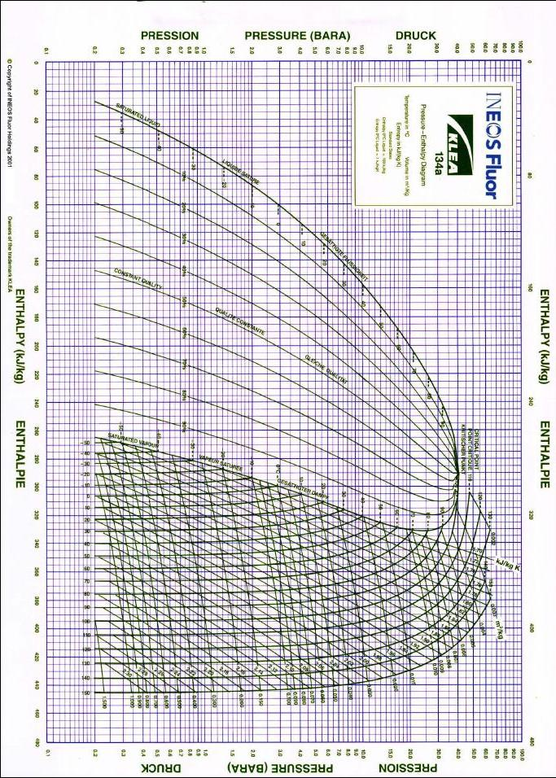
OBSERVATIONS TABLE FOR ALL EXPERIMENTS
Atmospheric Pressure = _____________mm Hg
Atmospheric Temperature =______________˚C
No. of obs. | Test | 1 | 2 | 3 | 4 | 5 | 6
Time 1 Rev. of meter | $$\frac{x}{s}$$
Mass flow rate | $$\frac{\dot{m_{r}}}{gs^{-1}}$$
Compressor suction (evaporator) pressure | $$\frac{P1}{kNm^{-2}}$$
Compressor delivery (condenser) pressure | $$\frac{P2}{kNm^{-2}}$$
Compressor suction temperature | $$\frac{T1}{˚C}$$
Compressor delivery temperature | $$\frac{T2}{˚C}$$
Condenser outlet temperature | $$\frac{T3}{˚C}$$
Evaporator inlet temperature | $$\frac{T4}{˚C}$$
Mass flow rate | $$\frac{ \dot{m_{w}}}{gs^{-1}}$$
Condenser inlet temperature | $$\frac{T5}{˚C}$$
Condenser outlet temperature | $$\frac{T6}{˚C}$$

