COMBUSTION IN SI ENGINES
Combustion of the air-fuel mixture inside the engine cylinder is one of the processes that controls engine power, efficiency, and emissions. Combustion in an engine is a very complex process which is not completely understood. Simplified models are used to describe this not-so-simple phenomenon. Combustion in an SI engine is quite different from combustion in a CI engine.
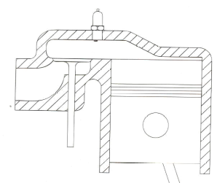
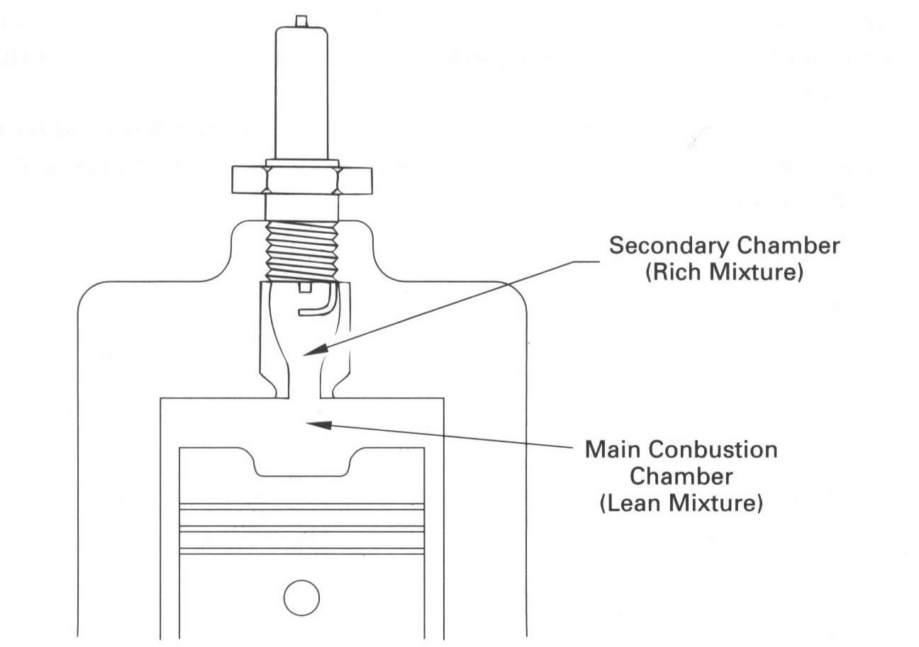
In spark-ignition engines, the fuel is normally mixed with air in the engine intake system. Following the compression of this air-fuel mixture and the residual gas, an electric discharge initiates the combustion process; a flame develops from the “kernal” created by the spark discharge and propagates across the cylinder to the combustion chamber walls. The combustion chamber is the area inside the engine where the fuel/air mixture is compressed and then ignited.
Old Chamber Design Flat Head Ford V8
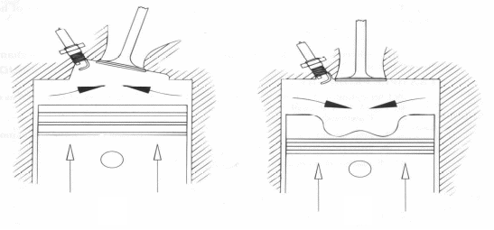
Combustion chamber is generally formed on one side by the shape cast into the cylinder head, and on the other side by the top of the piston. The engine's overall efficiency is affected by the shape of the chamber, shape of the top of the piston, and the location of valves and spark plug and overall airflow through the intake and exhaust. Combustion starts at the spark plug and the flame front travels from spark plug. At the walls, the flame is “quenched” or extinguished because of heat transfer. In an SI engine, combustion ideally consists of an exothermic subsonic flame progressing through a premixed homogeneous air-fuel mixture. The spread period of the flame front is greatly increased by induced turbulence, swirl, and squish within the cylinder.
Divided Chambers
Modern Chamber Designs showing squish
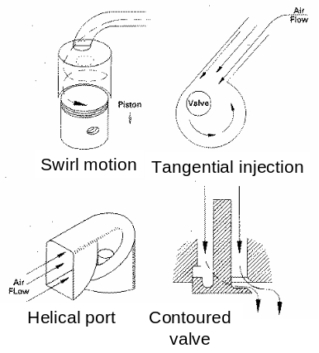
Swirl is the rotational flow about the cylinder axis. Swirl is used to promote rapid combustion in SI engines and rapidly mix fuel and air in direct injection SI engines.
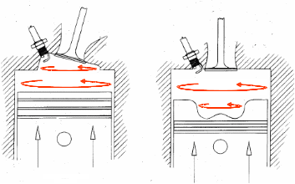
The swirl is generated during air induction into the cylinder by either tangentially directing the flow into the cylinder or pre-swirling the incoming flow by the use of helical ports. Many engines have a wedge shape cylinder head cavity or a bowl in the piston where the gas ends up at TDC. During the compression process as the piston approaches TDC more of the air enters the cavity with increased angular velocity and thus the swirl. When the piston reaches TDC at the end of the compression stroke, the volume around the outer edges of the combustion chamber is suddenly reduced to a very small value. Many modern combustion
chamber designs have most of the clearance volume near the centerline of the cylinder. As the piston approaches TDC, the gas mixture occupying the volume at the outer radius of the cylinder is forced radially inward as this outer volume is reduced to near zero. This radial inward motion of the gas mixture is called Squish. As the piston reaches TDC, squish motion generates a secondary rotational flow called Tumble.
Tumble
In SI engines, the combustion of air-fuel mixture occurs in a very short but finite length of time with the piston near TDC i.e., nearly constant-volume combustion. The heat addition is not instantaneous at TDC, as approximated in an Otto cycle. It starts near the end of the compression stroke slightly before TDC and lasts into the power stroke slightly after TDC. By starting combustion before TDC, cylinder pressure increases late in the compression stroke, requiring greater negative work in that stroke. Because combustion is not completed until after TDC, some power is lost at the start of expansion stroke. As the flame continues to grow and propagate across the combustion chamber, the pressure then steadily rise above the value it would have in the absence of combustion. Combustion changes the composition of the gas mixture to that of exhaust products and increases the temperature of the burned gases in the cylinder to a very high peak value. This, in turn, raises the pressure of the burned gases in the cylinder to a very high peak value. A fast but finite flame speed is desirable in an engine. This results in finite rate of pressure rise in the cylinders, a steady force increase on the piston face, and a smooth engine cycle. The pressure reaches a maximum after TDC but before the cylinder charge is fully burned, and then decreases as the cylinder volume continues to increase during the remainder of the expansion stroke.
The combustion process of spark-ignition engines can be divided into three broad regions:
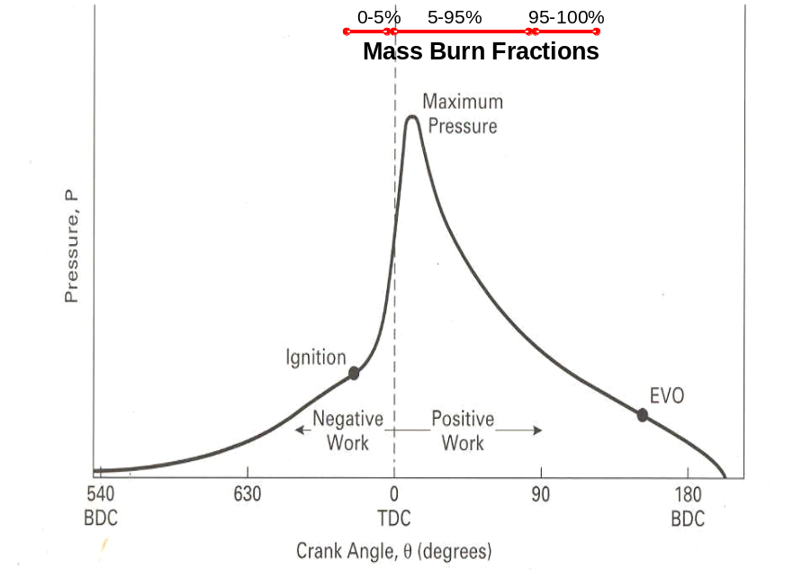
(1) Ignition and flame development;
(2) Flame propagation; and
(3) Flame termination
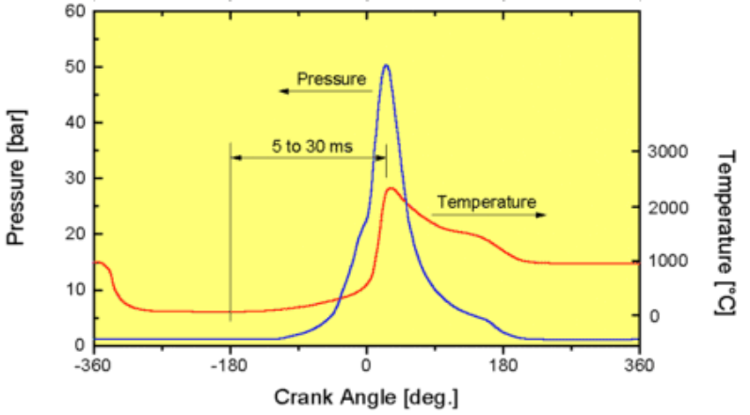
Flame development is generally considered the consumption of the first 5% of the air-fuel mixture (some sources use the first 10%). During the flame development period, ignition occurs and the combustion process starts, but very little pressure rise is noticeable and little or no useful work is produced. Just about all useful work produced in an engine cycle is the result of the flame propagation period of the combustion process. This is the period when the bulk of the fuel and air mass is burned (i.e., 80–90%, depending how defined). During this time, pressure in the cylinder is greatly increased, and this provides the force to produce work in the expansion stroke. The final 5% (some sources use 10%) of the air-fuel mass which burns is classified as flame termination. During this time, pressure quickly decreases and combustion stops.
Ideally the air-fuel mixture should be about two-thirds burned at TDC and almost completely burned at about 15°aTDC. This causes maximum temperature and maximum pressure of the cycle to occur somewhere between 5°and 10°aTDC, about optimum for a four-stroke cycle SI engine. Thus, combustion in a real four-stroke cycle SI engine is almost, but not exactly, a constant-volume process, as approximated by the ideal air-standard Otto cycle. The closer the combustion process is to constant volume, the higher will be the thermal efficiency.
True constant-volume combustion would give the pressure curve an infinite upward slope at TDC, with a corresponding rough engine operation. A lesser pressure rise rate gives lower thermal efficiency and danger of knock (i.e., a slower rise in pressure means slower combustion and the likelihood of knock). The combustion process is, thus, a compromise between the highest thermal efficiency possible (constant volume) and a smooth engine cycle with some loss of efficiency.
So far we have described normal combustion in which the spark-ignited flame moves steadily across the combustion chamber until the charge is fully consumed. In other words, a combustion process which is initiated solely by a timed spark and in which the flame front moves completely across the combustion chamber in a uniform manner at a normal velocity is called normal combustion. However, several factors⎯e.g., fuel composition, certain engine design and operating parameters, and combustion chamber deposits⎯may prevent this normal combustion process from occurring.
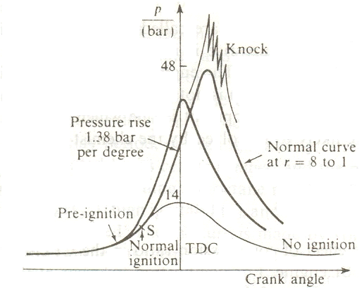
Abnormal combustion is a combustion process in which a flame front may be started by hot combustion-chamber surfaces either prior to or after spark ignition, or a process in which some part or all of the charge may be consumed at extremely high rates. Two types of abnormal combustion have been identified: knock and surface ignition. These abnormal combustion phenomena are of concern because: (1) when severe, they can cause major engine damage; and (2) even if not severe, they are regarded as an objectionable source of noise.
Knock is the most important abnormal combustion phenomenon.
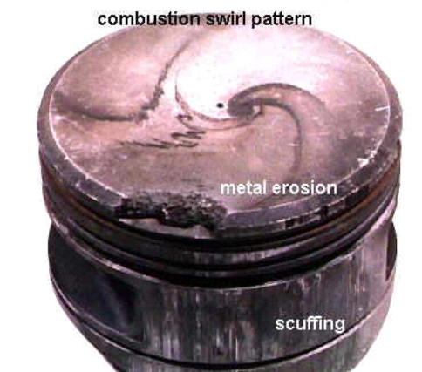
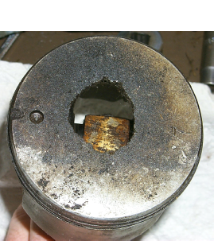
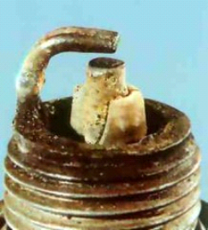
Knock is the name given to the noise that results from the autoignition of a portion of the fuel, air, residual gas mixture ahead of the advancing flame. As the flame propagates across the combustion chamber, the unburned mixture ahead of the flame⎯called the end gas⎯is compressed, causing its pressure, temperature and density to increase. Some of the end-gas fuel-air mixture may undergo chemical reactions prior to normal combustion. The products of these reactions may then autoignite: i.e., spontaneously and rapidly release a large part or all of their chemical energy. When this happens, the end gas burns very rapidly, releasing its energy at a rate 5 to 25 times that characteristic of normal combustion. This cause high frequency pressure oscillations inside the cylinder that produce the sharp metallic noise called knock. One of the results of knock is that local hot spots can be created which remain at a sufficiently high temperature to ignite the next charge before the spark occurs. This is called pre-ignition, and can help to
Combustion events leave trace on piston head
Detonation (heavy knock) waves cause metal degradation
High temperatures cause lubrication drop-out and scuffing
promote further knocking. The result is a noisy, overheated, and inefficient engine, and perhaps eventual mechanical failure. The cylinder pressure rises beyond its design limits and if allowed to persist, it will damage or destroy engine parts.
The presence and absence of knock reflects the outcome of a race between advancing flame front and the precombustion reactions in the unburned gas.
Knock will not occur if the flame front consumes the end gas before these reactions have time to cause the air-fuel mixture to autoignite. Knock will occur if the precombustion reactions produce autoignition before the flame front arrives. The right combination of fuel and operating characteristics is such that knock is avoided or almost avoided. Knocking can be prevented by:
- The use of a fuel with higher octane rating.
- The addition of octane-increasing “lead”.
- Increasing the amount of fuel injected/inducted (resulting in lower Air to Fuel Ratio).
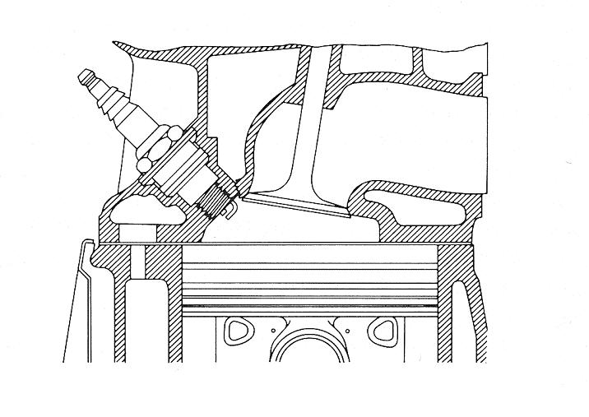
- Retardation of spark plug ignition.
Good combustion chamber design: Short flame paths and exhaust valve close to spark plug
- Use of a spark plug of colder heat range, in cases, where the spark plug insulator has become a source of pre-ignition leading to knock.
- Reduction of charge temperatures, such as through cooling.
- Proper combustion chamber design.
The other important abnormal combustion phenomenon is surface ignition.
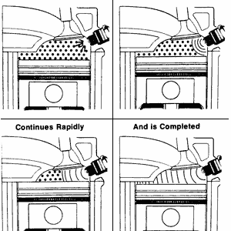
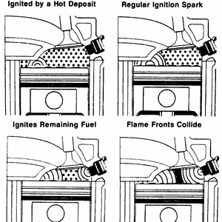
Surface ignition is ignition of the fuel-air mixture by a hot spot on the combustion chamber walls such as an overheated valve or spark plug, glowing combustion-chamber deposit; i.e., by any means other than the normal spark discharge. It may occur before the spark plug ignites the charge (preignition) or after normal ignition (postignition). It may produce a single flame or many flames. Uncontrolled combustion is most evident and its effect most severe when it results from preignition. However, even when surface ignition occurs after the spark plug fires (postignition), the spark discharge no longer has complete control of the combustion process. Following surface ignition, a turbulent flame develops at each surface-ignition location and starts to propagate across the chamber. Surface ignition may result in knock. Knock which occurs following normal spark ignition is called spark knock to distinguish it from knock which has been preceded by surface ignition. Spark-knock is controlled by the spark advance: advancing the spark increases the knock severity or intensity and retarding the spark decreases the knock. The knock phenomenon varies substantially cycle-by-cycle, and between the cylinders of a multi-cylinder engine, and does not necessarily occur every cycle. Since surface ignition usually cause a more rapid rise in end-gas pressure and temperature than normal spark ignition (because the flame either starts propagating sooner, or propagates from more than one source), knock is a likely outcome following the occurrence of surface ignition. To identify whether or not surface ignition causes knock, the terms knocking surface ignition and non-knocking surface ignition are used. Knocking surface ignition usually originates from preignition caused by glowing combustion chamber deposits: the severity of knock generally increases the earlier that preignition occurs.
Normal combustion
Pre-ignition
Knocking surface ignition cannot normally be controlled by retarding the spark timing, since the spark-ignited flame is not the cause of knock. Nonknocking surface ignition is usually associated with the surface ignition that occurs late in the operating cycle. Surface ignition is a problem that can be solved by appropriate attention to engine design, and fuel and lubricant quality. In contrast, knocking is an inherent constraint on engine performance and efficiency since it limits the maximum compression ratio that can be used with any given fuel. Knocking primarily occurs under wide-open-throttle operating conditions. It is thus a direct constraint on engine performance.

COMPRESSION RATIO OF SI ENGINES
Knocking also constraints engine efficiency, since by effectively limiting the temperature and pressure of the end-gas, it limits the engine compression ratio. The occurrence of severity of knock depends on the knock resistance of the fuel and on the antiknock characteristics of the engine. The ability of the fuel to resist knock is measured by its octane number: higher octane numbers indicate greater resistance to knock. Thermal efficiency of Otto cycle is given by
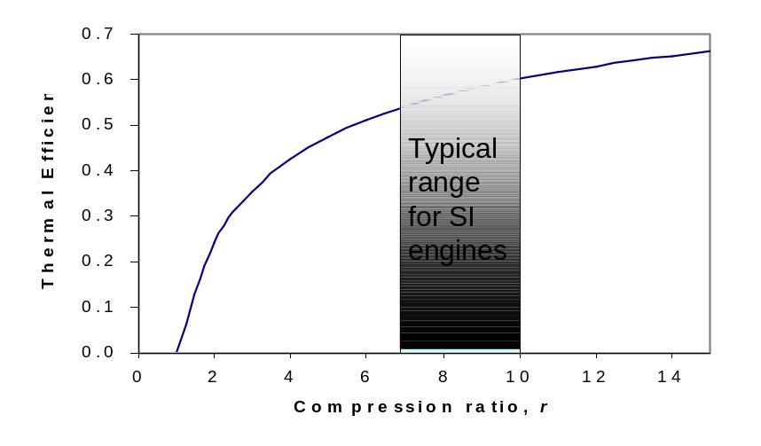
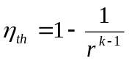
where the r is compression ratio.
A plot of thermal efficiency versus the compression ratio is shown in Figure for k = 1.4, which is the specific heat ratio value of air at room temperature. By increasing the compression ratio thermal efficiency increases. However, there is a limit on r depending upon the fuel. The thermal efficiency curve is steep at low compression ratios but flattens out starting with a compression ratio
value of about 8. Therefore, the increase in thermal efficiency with compression ratio is not that as pronounced at high compression ratios. Over the early years increases in compression ratio were made. However, since 1960 the compression ratios have not increased greatly and are in the range 9–10 for production vehicles in the UK. The ability to use higher compression ratios has depended on the provision of better-quality fuels and of improved design of combustion chamber. Gasoline octane ratings can be improved by refining processes, such as catalytic cracking and reforming, which convert low-octane hydrocarbons to high-octane hydrocarbons. Also, antiknock additives such as alcohol, lead alkyls, or an organomanganese compound can be used. When high compression ratios are used, the temperature of the air-fuel mixture in an SI engine rises above the autoignition temperature of the fuel (the temperature at which the fuel ignites without the help of a spark) during the combustion process, causing an early and rapid burn of the fuel at some point or points ahead of the flame front, followed by almost instantaneous inflammation of the end gas. This premature ignition of the fuel, called autoignition, produces an audible noise, which is called engine knock. Autoignition occurs because compression of the fuel-air mixture raises its temperature too high. Autoignition in SI engines cannot be tolerated because it hurts performance and can cause engine damage. The requirement that autoignition not be allowed places an upper limit on the compression ratios that can be used in spark-ignition internal combustion engines. Since knock is undesirable, the engine designer must limit the compression ratio so that it does not occur. This is one factor that limits the efficiency of gasoline engines. Improvement of the thermal efficiency of SI engines by utilising higher compression ratios (up to about 12) without facing the autoignition problem has been made possible by using gasoline blends that have good antiknock characteristics, such as gasoline mixed with tetraethyl lead. Tetraethyl lead has been added to gasoline since the 1920s because it is an inexpensive method of raising the octane rating, which is a measure of the engine knock resistance of the fuel. Leaded gasoline, however, has a very undesirable side effect: it forms compounds during the combustion process that are hazardous to health and pollute the environment. In an effort to combat air pollution, the government adopted a policy in the mid-1970s that resulted in the eventual phase-out of leaded gasoline. Unable to use lead, the refiners developed other techniques to improve the antiknock characteristics of gasoline. Most cars made since 1975 have been designed to use unleaded gasoline, and the compression ratios had to be lowered to avoid engine knock. The thermal efficiency of car engines has decreased somewhat as a result of decreased compression ratios. However, owing to the improvements in other areas (reduction in overall automobile weight, improved aerodynamic design, etc.), today’s cars have better fuel economy. This is an example of how engineering decisions involve compromises, and efficiency is only one of the considerations in final design. With higher compression ratio engines other phenomena are observed. From compression ratios of 9.5/1 upwards there are high rates of pressure rise which have their origin in the additional flame fronts started form surface deposits in the cylinder. At about 9.5/1 compression ratio the low frequency engine vibration produced are called rumble or pounding. At compression ratios of 12/1 the pressure rise is about 8.3 bar per degree crank angle with a peak pressure of 83 bar. The engine noises produced are known as thud or pressure rap; surface ignition is not present and characteristic have little influence. This field of development is one which brings many new problems which are more likely to be solved by the chemist than the engineer.
Octane Number: The compression ratio which can be utilized depend on the fuel to be used and a scale has been developed against which the knock tendency of a fuel can be rated. The rating is given as an octane number (ON). The fuel under test is compared with a mixture of iso-octane (high rating) and normal heptane (low rating), by volume. The octane number of the fuel is the percentage of octane in the reference mixture which knocks under the same conditions as the fuel. The octane rating is a measure of the autoignition resistance of gasoline (petrol) and other fuels used in spark-ignition internal combustion engines. It is a measure of anti-knocking of a gasoline or fuel. Octane number is the number which gives the percentage, by volume, of iso-octane in a mixture of iso-octane and normal heptane, that would have the same anti-knocking capacity as the fuel which is under consideration. For example, gasoline with the same knocking characteristics as a mixture of 90% iso-octane and 10% heptane would have an octane rating of 90. The octane ratings of n-heptane and iso-octane are respectively exactly 0 and 100, by definition.
For some other hydrocarbons, the following are the road octane numbers:
n-octane –10 n-heptane 0 2-methylheptane 23 n-hexane 25 1-heptene 60 n-pentane 62 1-pentene 84 n-butane 91 cyclohexane 97 isooctane 100 benzene 101 Methane 107 Ethane 108 Toluene 114 Xylene 117
The number obtained depends on the conditions of the test and the two main methods in use (the research and the motor methods) give different ratings for the same fuel. The motor test is carried out at the higher temperature and give the lower rating. The difference between the two is taken as a measure of the temperature sensitivity of the fuel. High-octane fuels (up to 100) can be produced by refining techniques, but it is done more cheaply and more frequently by the use of anti-knock additives, such as tetraethyl lead. An addition of 1.1 cm3 of tetraethyl lead to 1 litre of 80-octane petrol increases the octane number to 90. Unfortunately it has been shown that the levels of lead in the atmosphere due to SI engine are harmful to health. Fuel has been developed which have a higher anti-knock rating than iso-octane and this has led to an extension of the octane scale. Aviation conditions of operation lead to another scale which gives a better indication of the detonation (heavy knock) characteristics; this is the performance number (PN). The relationship between ON above 100 and PN is given by: ON above 100 = 100+ 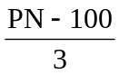
Effects of Octane Rating: Higher octane ratings correlate to higher activation energies. Activation energy is the amount of energy necessary to start a chemical reaction. Since higher octane fuels have higher activation energies, it is less likely that a given compression will cause knocking. (Note that it is the absolute compression pressure in the combustion chamber which is important and not the compression ratio. The compression ratio only governs the maximum compression that can be achieved).
Partial Burning in SI Engines: As the mixture becomes leaner the excess air or more dilute with a higher burned gas fraction from residual gases or exhaust gas recycle, the magnitude of cycle-by-cycle combustion variations increases. Eventually, some cycles become sufficiently slow burning that combustion is not completed by the time the exhaust opens: a regime where partial burning occurs in a fraction of the cycles is encountered. For even when leaner or more dilute mixtures, the misfire limit is reached. At this point, the mixture in a fraction of the cycles fails to ignite. While spark ignition engines will continue to operate with a small percentage of the cycles in the partial-burn or misfire regimes, such operation is obviously undesirable from the point of efficiency, hydrocarbon emissions, torque variations, and roughness. The unburned gases in front of the flame front are compressed by this higher pressure, and compressive heating raises the temperature of the gas. The temperature of the unburned gas is further raised by radiation heating from the flame, and this then raises the pressure even higher.
Heat transfer by conduction and convection are not important during this process due to the very short time interval involved. As the flame moves through the combustion chamber, it travels through an environment that is progressively increasing in temperature and pressure. This causes the chemical reaction time to decrease and the flame front speed to increase, a desirable result. As the unburned mixture in an SI engine is leaned out with excess air or is diluted with increasing amounts of burned residual gas and exhaust gas recycle, the flame development period, the duration of the rapid burning phase, and the cycle-by-cycle fluctuations in the combustion process all increase. | 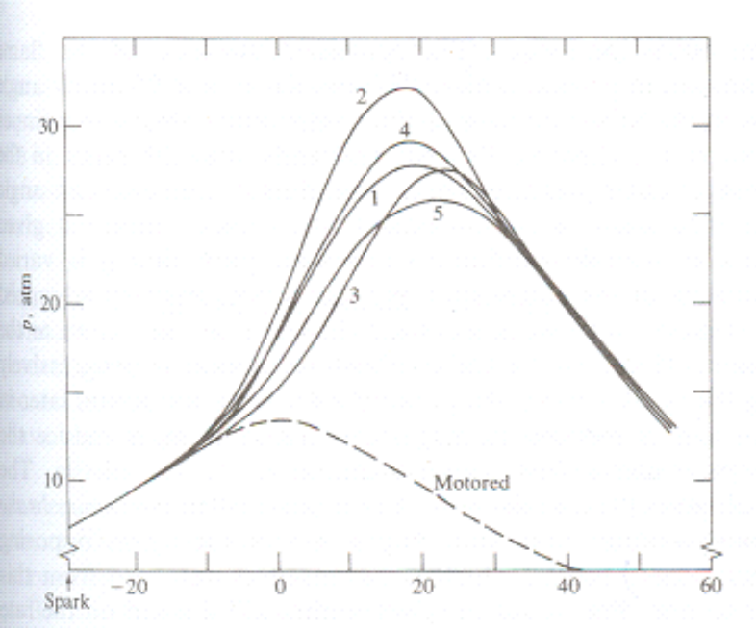
Eventually a point is reached where engine operation becomes rough and unstable, and hydrocarbon emissions increase rapidly. The point at which these phenomena occur effectively defines the engine’s stable operating limit. The proportion of partial burning or nonburning cycles increase rapidly if the mixture is made even more lean or dilute, and the point is soon reached where the engine will not run at all. Combustion in a compression-ignition engine is quite different from that in an SI engine. Whereas combustion in an SI engine is essentially a flame front moving through a homogeneous mixture, combustion in a CI engine is an unsteady process occurring simultaneously at many spots in a very non-homogeneous mixture at a rate controlled by fuel injection. Air intake into the engine is unthrottled, with engine torque and power output controlled by the amount of fuel injected per cycle.

