Experiment # 01
The Heading of the experiment number should be “Time New Romans” and font size should be “12” and bold and centered. The text should be justified on both sides of the paper.
Objective: The objective heading should be “Time New Romans” and font size should be “14” and bold. And text should be “Time New Romans” and font size should be “12”. The text should be justified on both sides of the paper.
Apparatus: The apparatus heading should be “Time New Romans” and font size should be “14” and bold. And text should be “Time New Romans” and font size should be “12”. The text should be justified on both sides of the paper.
Procedure: The procedure heading should be “Time New Romans” and font size should be “14” and bold. And text should be “Time New Romans” and font size should be “12”. The text should be justified on both sides of the paper.
Theory: All the headings in theoretical portion should be “Time New Romans” and font size should be “14” and bold. And text should be “Time New Romans” and font size should be “12”. The text should be justified on both sides of the paper.
Observations & Calculations
All the text in the tables and calculations should be “Time New Romans” and font size should be “12”. The text in tables should be justified and centered as shown in the sample text below. The title of the table would be above the table with the relevant number as Table 1, Table 2 etc.
All the relevant calculations should be after the table of observations. The results of the experiment obtained from this section would also be discussed here. The figures should also be centered and justified and the size of figures should be equal in length and width. The figure title should be below the figure and centered and justified as shown in sample text. You must mention about the figure in the text like “as shown in Figure 1” etc. as shown in sample text below. The relevant figure should be after the text. The line spacing should be 1.5

Sample Text
The sample text is starting from 4.5, you will start it in each experiment from 1.0, the subheadings will be 1.1, 1.2, 1.3….. etc.

4.5 Refrigerator Cooling Kit Design

The cooling kit used for cooling purpose in thermoelectric refrigerators consists of a Thermoelectric Module, a Heat Sink and a Cooling Fan. A brief description about the selection of these components is as follows:

4.5.1 Selection of Suitable Thermoelectric Module Material

Semiconductor materials are the only choice to sandwich amongst two metal conductors due to their capability to control the charge carriers and to increase the heat impelling capacity. Figure 4.2 shows a typical configuration of P-Type and N-Type semiconductor materials used in a thermoelectric module. The performance of thermoelectric modules greatly depends upon the temperature gradient of its hot and cold sides, the thermal conductivity and electrical resistance of the module material, the contact resistance of the thermoelectric module and heat sink, and the thermal resistance of heat sink.
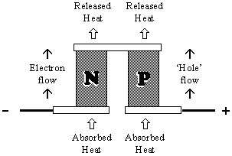

Figure 4.2: Schematic of P-Type & N- Type Thermoelectric Pellet [21]

Bi₂Te₃ is a semiconductor material used mostly for electronics cooling due to its high Figure of Merit. Figure of Merit represents the quality of performance of a thermoelectric material. It is multiplied sometimes by temperature to get its value in significant numbers up to one decimal place. It is well-defined as: z = α/ρk, where “α” is SeeBeck coefficient, “ρ” is electrical resistivity and “k” is thermal conductivity of thermoelectric material. Alternate materials are also being explored with probably better performance by changing thin film coatings of Sb₂Te_{3,} Bi₂Te₃, Lead telluride, SiGe etc.
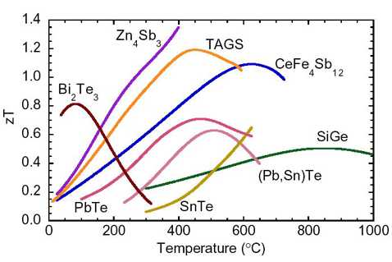

Figure 4.3: zT for P-Type Thermoelectric Materials [22]

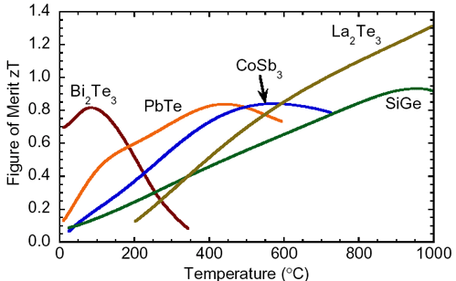

Figure 4.4: zT for N-Type Thermoelectric Materials [22]

Numerous P-Type and N-Type semiconductor materials Figure of Merit vs. Temperature graphs are shown in Figure 4.3 and 4.4. The graphs show the performance quality of different thermoelectric materials for various temperature ranges. As the maximum and minimum temperatures in this research work are taken as 40 ºC and 10 ºC respectively and it is clear from Figure 4.3 and 4.4 that for 0-200°C temperature range, Bi₂Te₃ performs the best. Hence, Bi₂Te₃ has been chosen for thermoelectric module in the present work.

4.5.2 Methodology for Sizing and Selecting Thermoelectric Module

The cooling capacity of a thermoelectric module is an important parameter when it is used in refrigerator for cooling purpose. It should be capable to meet the maximum cooling requirements of a specific refrigeration space. In order to select a module of desired cooling capacity, different companies have different methodologies. Most companies have current, performance, temperature etc. statistics for their definite modules which can be used for the selection of desired thermoelectric module. The selection procedure of a thermoelectric module is as follows:

Step 1: Calculate the total amount of heat to be impelled (Qc), lowest desired temperature (T_{R}), maximum possible ambient temperature (Ta) and the temperature gradient (DTmax) of hot and cold side of thermoelectric module. Normally, the extreme permissible temperature gradient across thermoelectric module sides is specified by the manufacturers. As a rule of thumb typical hot side temperature is taken as 10-15 ºC above that of ambient temperature, and cold side temperature 3-6 ºC below that of load temperature.
Step 2: Describe the least number of stages for the allowable temperature gradient as specified in step 1. The maximum achievable temperature gradient for single, double and triple stage thermoelectric modules is 68 ºC, 84 ºC and 110 ºC, respectively.

Step 3: Compute the operational current I and voltage V by assuming that Qc is the maximum amount of heat that could be removed by thermoelectric module. In the present work, the operational current and voltage is mentioned by manufacturer and hence are not calculated separately. These are shown in Table 4.3
Step 4: Calculate the power consumed by thermoelectric module, the heat dissipated to the heat sink, and the coefficient of performance of the thermoelectric module. All these parameters could be found by using the following relations.

P = VI Qh = Qc + P COP = Qc/P
4.5.3 Specifications of Desired Thermoelectric Module

The required specifications of a desired thermoelectric module are enlisted in Table 4.2. The cooling load, maximum ambient temperature, and minimum refrigeration space temperature have been already calculated previously. The hot side temperature of the module is taken as 10ºC above the maximum ambient temperature, while the cold side temperature of the module is taken as 3ºC below that of refrigerator temperature. Hence the temperature gradient across the thermoelectric module would be 43 ºC, which is less than the maximum allowable temperature gradient of 68 ºC as mentioned in Table 4.3 for single stage TEM.

Table 4.2 Characteristic and Specifications of Desired Thermoelectric Cooler

Item | Symbol | Value | Unit
Total amount of heat (cooling load) to be impelled | $\dot{Q}$c | 57.52 | Watts
Minimum heat load temperature | T_{R} | 10.0 | ºC
Maximum ambient temperature | Ta | 40.0 | ºC
TEC hot side Temperature | Th | 50.0 | ºC
TEC cold side Temperature | Tc | 7.0 | ºC
Temperature gradient of hot and cold sides | ΔT | 43.0 | ºC
TEC maximum temperature gradient | DTmax | 68.0 | ºC
Number of stages necessary for DTmax | Single Stage TEC | 1.0 | --

4.5.4 Selection of appropriate Single stage Thermoelectric Cooler

The specifications of various thermoelectric modules are enlisted in Table 4.3. These specifications are given by a Thermoelectric Modules manufacturing company named as Thermonamic Technology Inc. [20]. These specifications have been used for the selection of appropriate module for the present research work.

